Algorithms

{

<https://www.youtube.com/watch?v=0IAPZzGSbME&list=PLDN4rrl48XKpZkf03iYFl-O29szjTrs_O>

}

**Introduction to Algorithms**

1. **Importance of Algorithms:**

- Algorithms are fundamental in computer science and programming contests.

- They are crucial for competitive exams and job interviews.

| **Aspect** | **Algorithm** | **Program** |
| --- | --- | --- |
| **Definition** | A step-by-step procedure to solve a computational problem. | An implementation of an algorithm in a specific programming language. |
| **Purpose** | To design and conceptualize the solution. | To execute the solution on a computer. |
| **Development Phase** | Created during the design phase of software development. | Developed during the implementation phase. |
| **Language** | Written in plain English or pseudocode; not specific to any hardware or OS | Written in a programming language (e.g., C, C++, Java). |
| **Machine Independence** | Not dependent on hardware or operating system. | Dependent on hardware and operating system. |
| **Focus** | Logical sequence and problem-solving strategy. | Syntax and machine-level implementation. |
| **Roles** | Designed by those with domain knowledge or problem expertise. | Implemented by programmers who translate the design into code. |
| **Analysis** | Analyzed for efficiency (time and space complexity). | Tested to ensure correctness and functionality. |
| **Language Use** | Can use any understandable language or notation (e.g., pseudocode). .( mathematical notations are good to have if needed ) | Typically written in a programming language, often C for simplicity. |

**1.1 Priori Analysis and Posteriori Testing**

| **Aspect** | **Pre-Analysis (Algorithms)** | **Post-Analysis (Programs)** |
| --- | --- | --- |
| **Definition** | Analysis of an algorithm to understand its efficiency and behavior. | Testing of a program to measure its performance and resource usage. |
| **Objective** | Evaluate theoretical aspects like time and space complexity. | Measure actual execution time and memory consumption. |
| **Method** | Study the algorithm’s steps and derive its time and space complexities. | Run the program and collect data on execution time and memory usage. |
| **Independence** | Hardware and language independent. | Hardware, language, and operating system dependent. |
| **Results** | Time complexity (e.g., O(n), O(log n)) and space complexity (e.g., O(1)). | Actual time (e.g., seconds, milliseconds) and memory usage (e.g., bytes). |
| **Tools** | Analytical methods and theoretical models. | Profiling tools and runtime measurements. |

**Characteristics of an Algorithm**

| **Characteristic** | **Description** |
| --- | --- |
| **Input** | An algorithm must take zero or more inputs. It can handle no input, one input, or multiple inputs. |
| **Output** | An algorithm must produce at least one output. It should generate a result or answer after processing. |
| **Definiteness** | Every statement in an algorithm must be clear and unambiguous. Each step should have a single, exact meaning. |
| **Finiteness** | An algorithm must terminate after a finite number of steps. It should have a clear stopping point. |
| **Effectiveness** | All operations in an algorithm should be necessary and contribute to achieving the objective. Unnecessary steps should be avoided. |

**Examples and Analogies:**

* **Input/Output:** Similar to functions in programming; a function may not take parameters but should return some result.
* **Definiteness:** Each statement should be precise and understandable; no ambiguous or undefined values should be used.
* **Finiteness:** Like a cooking recipe or a laboratory experiment, an algorithm must have a clear end point and complete in a finite number of steps.
* **Effectiveness:** Avoid unnecessary steps; every action should have a purpose related to the goal of the algorithm.

**Algorithm Analysis**

**Characteristics of Algorithm Analysis**

| **Aspect** | **Description** |
| --- | --- |
| **Time Analysis** | Measures how much time an algorithm takes to complete based on its steps and operations. |
| **Space Analysis** | Measures the amount of memory an algorithm uses, considering variables and data storage. |

**Time Analysis**

1. **Definition**: Evaluates the duration an algorithm takes to execute. This is often represented as a function of input size nnn.
2. **Measurement**:
   * **Unit Time**: Each basic operation (e.g., addition, assignment) is assumed to take a constant unit of time.
   * **Function Representation**: The time complexity is expressed as a function, such as f(n)f(n)f(n), representing how time grows with input size.
   * **Constant Time**: For simple algorithms with a fixed number of steps, time complexity can be constant (e.g., O(1)O(1)O(1)).
   * **Detailed Analysis**: For more complex algorithms, detailed analysis might consider the conversion to machine code and exact operations.

**Space Analysis**

1. **Definition**: Evaluates the amount of memory an algorithm requires, including space for input, output, and variables.
2. **Measurement**:
   * **Variable Count**: Count the number of variables and their types to estimate space usage.
   * **Constant Space**: If the space required does not grow with input size, it is considered constant (e.g., O(1)O(1)O(1)).
   * **Detailed Analysis**: This might involve counting memory in terms of words or bytes and considering different variable types.

**Examples**

* **Time Complexity**: If an algorithm performs a fixed number of operations regardless of input size, it is constant time O(1)O(1)O(1). For example, simple arithmetic operations or fixed loops.
* **Space Complexity**: If an algorithm uses a constant amount of space, regardless of input size, it is constant space O(1)O(1)O(1). For example, a function using a fixed number of variables.

**Additional Criteria**

* **Data Transfer**: Consider how much data is transferred or processed, especially for network-based or cloud applications.
* **Power Consumption**: For hardware or embedded systems, power usage may be a factor.
* **CPU Usage**: For low-level or system programming, CPU cycles and register usage might be analyzed.

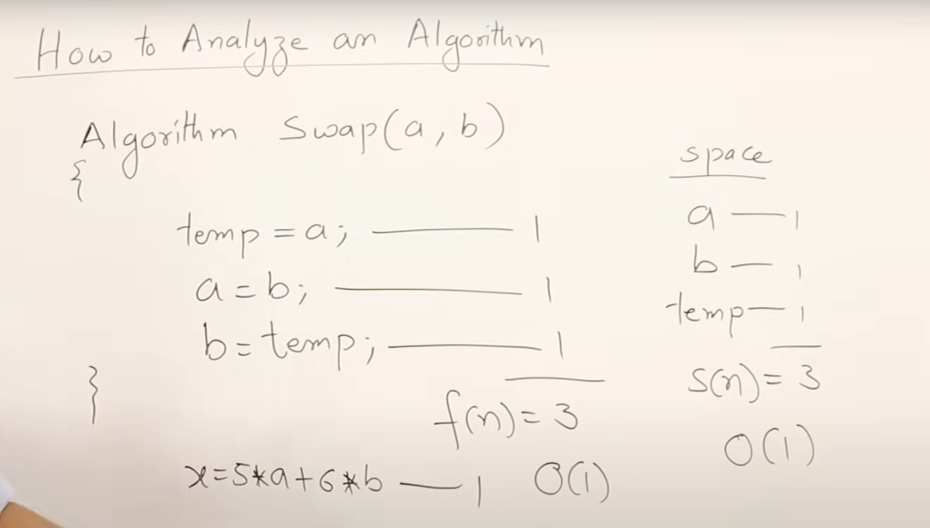

Here O() means orderOf ( not bigO of )

the frequency count method to analyze time and space complexity, demonstrating with examples of algorithms for summing array elements, adding matrices, and matrix multiplication, highlighting complexities of O(n), O(n²), and O(n³) respectively.

**Frequency Count Method for Analyzing Algorithms**

**@**<https://www.youtube.com/watch?v=1U3Uwct45IY>

**1. Sum of Array Elements**

**Algorithm**: Finding the sum of all elements in an array.

**Example**: Array of size nnn (e.g., n=5n = 5n=5).

**Time Complexity Analysis**:

* **Statements**:
  1. Initialization: Takes constant time.
  2. Loop: Runs nnn times, summing elements.
* **Execution Frequency**:
  1. Loop runs nnn times.
  2. Condition check for the loop runs n+1n + 1n+1 times.
  3. Summation inside the loop runs nnn times.
* **Total Time**: 2n+12n + 12n+1 (constant factors are omitted for simplicity).

**Time Complexity**: O(n)O(n)O(n)

**Space Complexity Analysis**:

* **Variables**: Array AAA of size nnn, and a few additional variables (constant size).
* **Space Usage**: nnn (array size) + constant (additional variables).

**Space Complexity**: O(n)O(n)O(n)

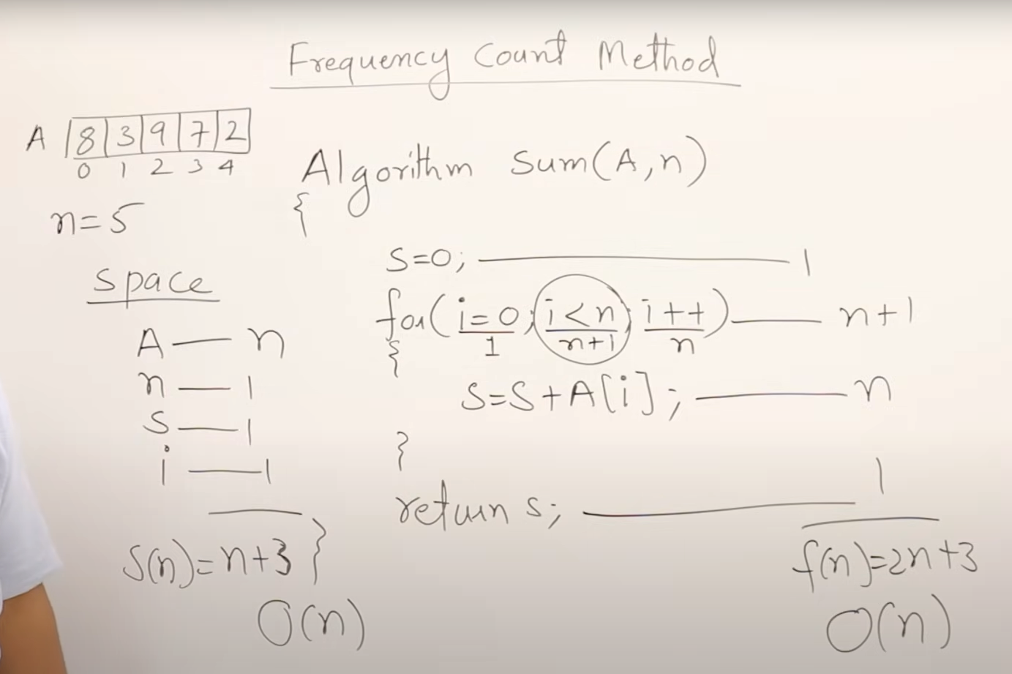

**2. Sum of Two Matrices**

**Algorithm**: Adding two n×nn \times nn×n matrices.

**Example**: Matrices AAA and BBB, both of size n×nn \times nn×n.

**Time Complexity Analysis**:

* **Statements**:
  1. Initialization: Takes constant time.
  2. Loop: Runs n2n^2n2 times to sum corresponding elements.
* **Execution Frequency**:
  1. Outer loop runs nnn times.
  2. Inner loop runs nnn times per outer loop iteration.
  3. Total iterations: n×n=n2n \times n = n^2n×n=n2.

**Time Complexity**: O(n2)O(n^2)O(n2)

**Space Complexity Analysis**:

* **Variables**: Three matrices (each n×nn \times nn×n), and scalar variables (constant size).
* **Space Usage**: 3n23n^23n2 (matrices) + constant (additional variables).

**Space Complexity**: O(n2)O(n^2)O(n2)

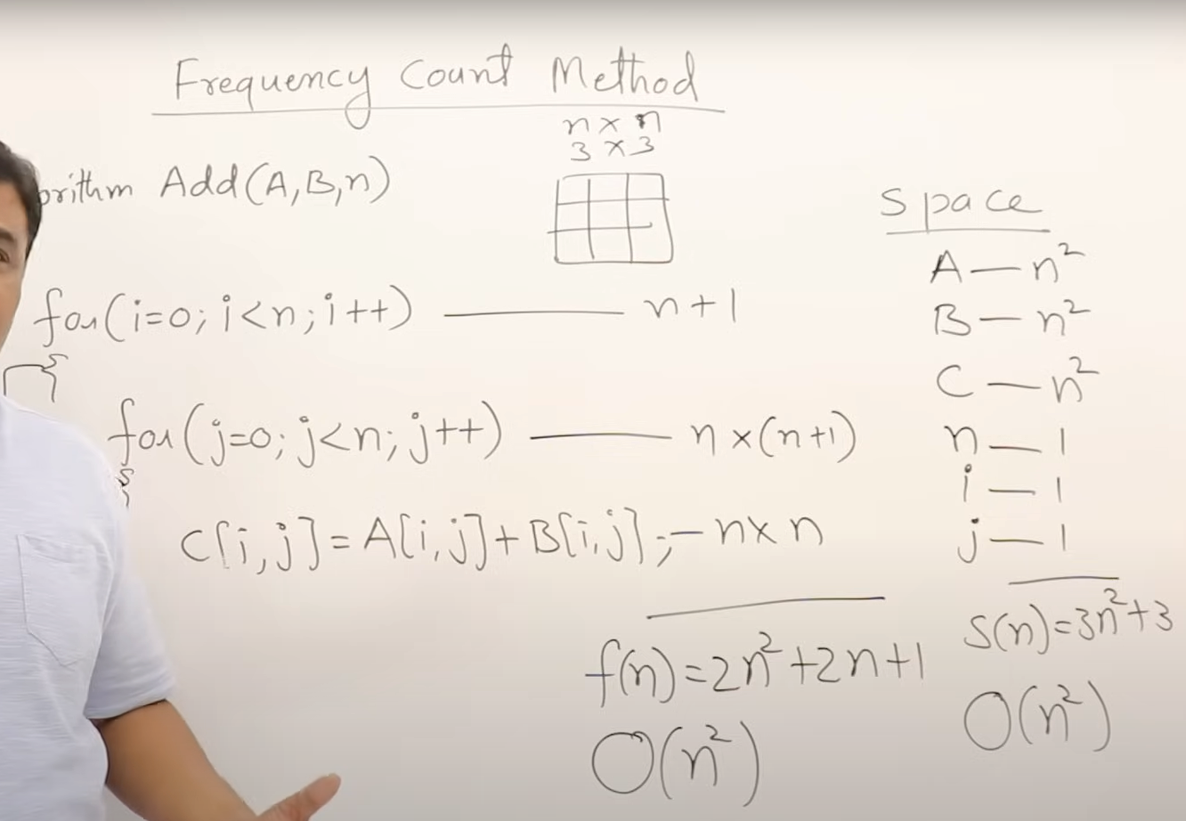

**3. Multiplication of Two Matrices**

**Algorithm**: Multiplying two n×nn \times nn×n matrices.

**Example**: Matrices AAA and BBB, both of size n×nn \times nn×n.

**Time Complexity Analysis**:

* **Statements**:
  1. Initialization: Takes constant time.
  2. Triple Nested Loop: Runs n3n^3n3 times for matrix multiplication.
* **Execution Frequency**:
  1. Each of the three nested loops runs nnn times.
  2. Total iterations: n×n×n=n3n \times n \times n = n^3n×n×n=n3.

**Time Complexity**: O(n3)O(n^3)O(n3)

**Space Complexity Analysis**:

* **Variables**: Three matrices (each n×nn \times nn×n), and scalar variables (constant size).
* **Space Usage**: 3n23n^23n2 (matrices) + constant (additional variables).

**Space Complexity**: O(n2)O(n^2)O(n2)

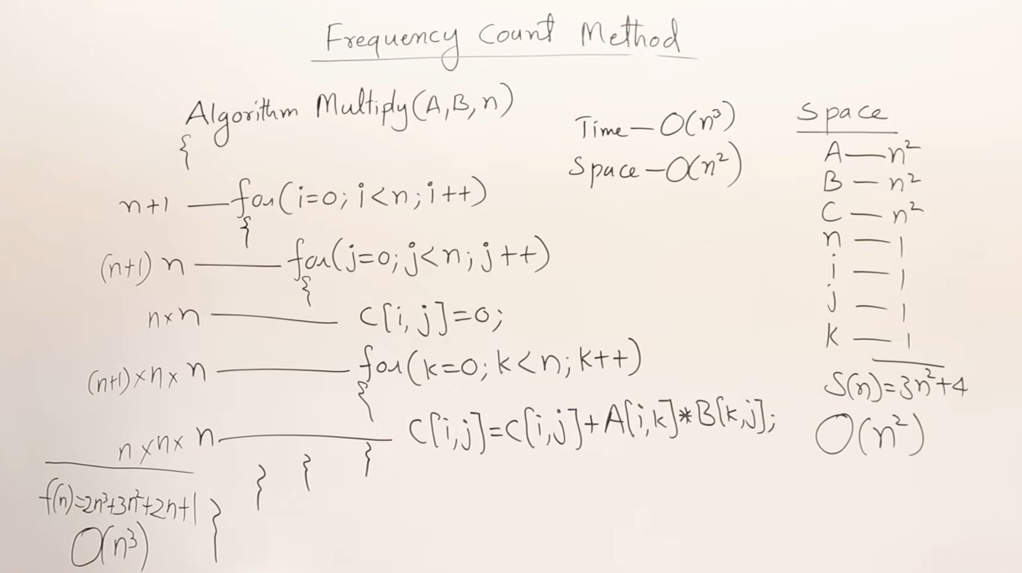

If nested loops and all loops run n times, then inner loop’s n repeatetion is basically the Order of n power item…

Here’s a structured summary of how to analyze the time complexity of various code snippets using frequency count and other methods. This includes examples of simple loops, nested loops, and more complex cases.

---

### **Analyzing Code Complexity**

#### **1. Simple Loop**

**Code Snippet**:

```c

for (int i = 0; i < n; i++) {

// Constant time operation

}

```

**Analysis**:

- **Execution**: The loop runs \( n \) times.

- **Time Complexity**: \( O(n) \)

- **Space Complexity**: \( O(1) \) (only a constant amount of space is used)

**Note**: The \( +1 \) in the loop condition does not affect the overall time complexity as it’s a constant factor.

---

#### **2. Decrementing Loop**

**Code Snippet**:

```c

for (int i = n; i > 0; i--) {

// Constant time operation

}

```

**Analysis**:

- **Execution**: The loop runs \( n \) times, decrementing from \( n \) to 1.

- **Time Complexity**: \( O(n) \)

- **Space Complexity**: \( O(1) \)

**Note**: Whether counting up or down, the number of iterations remains \( n \).

---

#### **3. Incrementing by 2**

**Code Snippet**:

```c

for (int i = 0; i < n; i += 2) {

// Constant time operation

}

```

**Analysis**:

- **Execution**: The loop runs approximately \( n/2 \) times.

- **Time Complexity**: \( O(n) \)

- **Space Complexity**: \( O(1) \)

**Note**: Incrementing by any constant factor does not change the order of the time complexity; it remains \( O(n) \).

---

#### **4. Nested Loops**

**Code Snippet**:

```c

for (int i = 0; i < n; i++) {

for (int j = 0; j < n; j++) {

// Constant time operation

}

}

```

**Analysis**:

- **Execution**: Outer loop runs \( n \) times; for each iteration, inner loop runs \( n \) times.

- **Total Execution**: \( n \times n = n^2 \).

- **Time Complexity**: \( O(n^2) \)

- **Space Complexity**: \( O(1) \) (assuming only constant space used aside from input)

---

#### **5. Nested Loops with Conditional Limits**

**Code Snippet**:

```c

for (int i = 0; i < n; i++) {

for (int j = 0; j < i; j++) {

// Constant time operation

}

}

```

**Analysis**:

- **Execution**: The inner loop executes \( i \) times for each value of \( i \).

- **Total Execution**: \( 0 + 1 + 2 + ... + (n-1) = \frac{n(n-1)}{2} \approx \frac{n^2}{2} \).

- **Time Complexity**: \( O(n^2) \)

- **Space Complexity**: \( O(1) \)

---

#### **6. Sum of Incrementing Values**

**Code Snippet**:

```c

int P = 0;

for (int i = 1; P <= n; i++) {

P += i;

}

```

**Analysis**:

- **Execution**: The loop continues until the sum \( P \) exceeds \( n \). The sum of the first \( k \) integers is \( \frac{k(k+1)}{2} \).

- **Condition**: \( \frac{k(k+1)}{2} \approx n \), so \( k \approx \sqrt{2n} \).

- **Time Complexity**: \( O(\sqrt{n}) \)

- **Space Complexity**: \( O(1) \)

---

### **Summary**

1. **Simple Loop**:

- **Time Complexity**: \( O(n) \)

- **Space Complexity**: \( O(1) \)

2. **Decrementing Loop**:

- **Time Complexity**: \( O(n) \)

- **Space Complexity**: \( O(1) \)

3. **Incrementing by 2**:

- **Time Complexity**: \( O(n) \)

- **Space Complexity**: \( O(1) \)

4. **Nested Loops**:

- **Time Complexity**: \( O(n^2) \)

- **Space Complexity**: \( O(1) \)

5. **Nested Loops with Conditional Limits**:

- **Time Complexity**: \( O(n^2) \)

- **Space Complexity**: \( O(1) \)

6. **Sum of Incrementing Values**:

- **Time Complexity**: \( O(\sqrt{n}) \)

- **Space Complexity**: \( O(1) \)

This summary provides an overview of analyzing the time complexity of different types of loops and conditions in code. It covers how to approach each case and determine its computational complexity effectively.

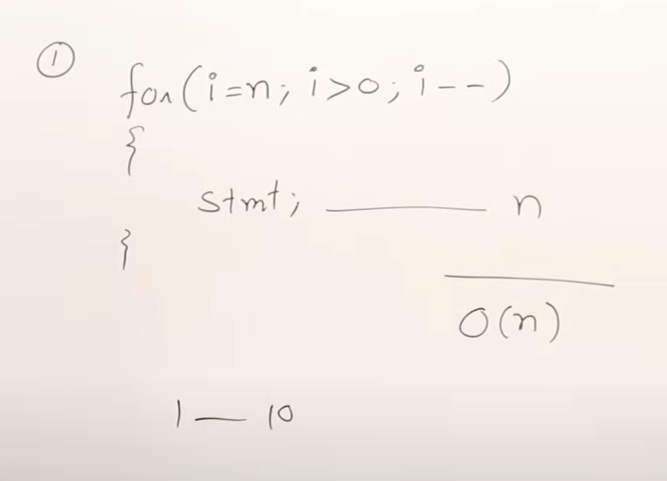

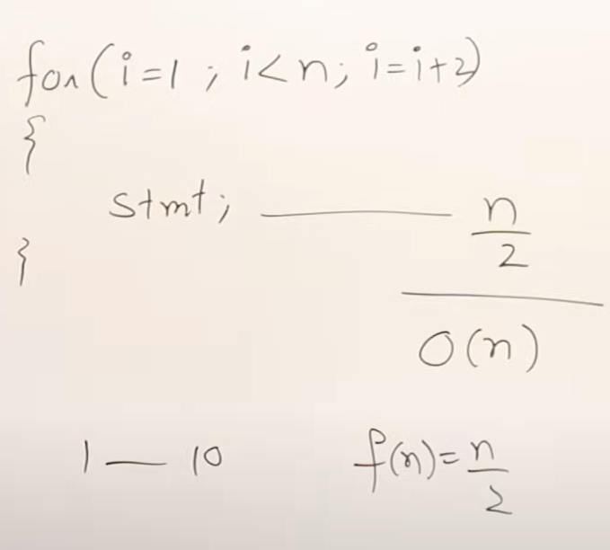

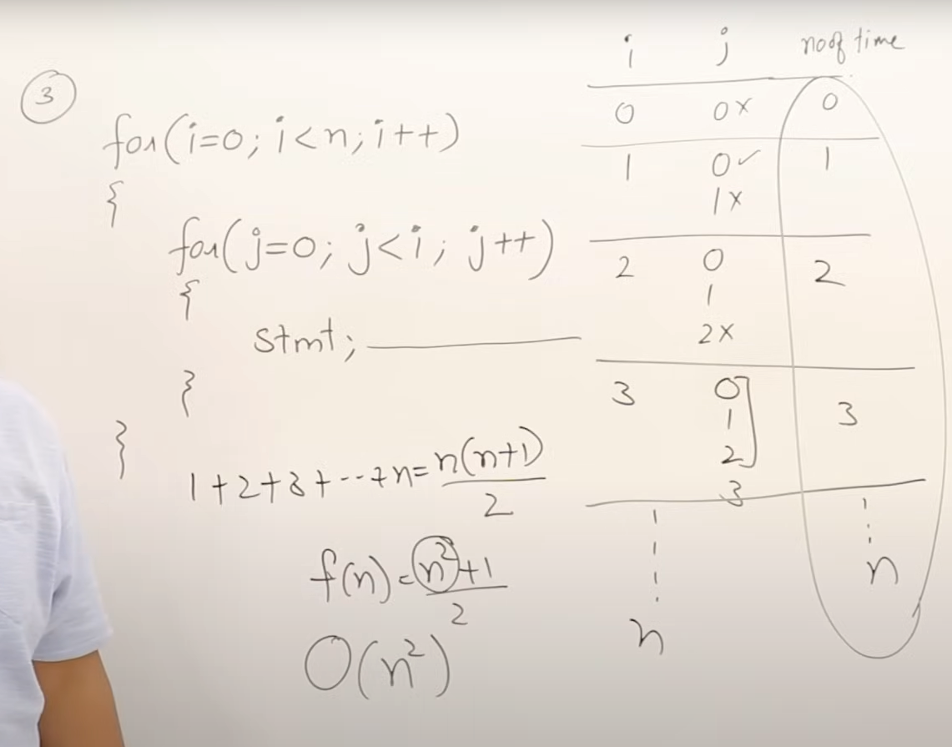

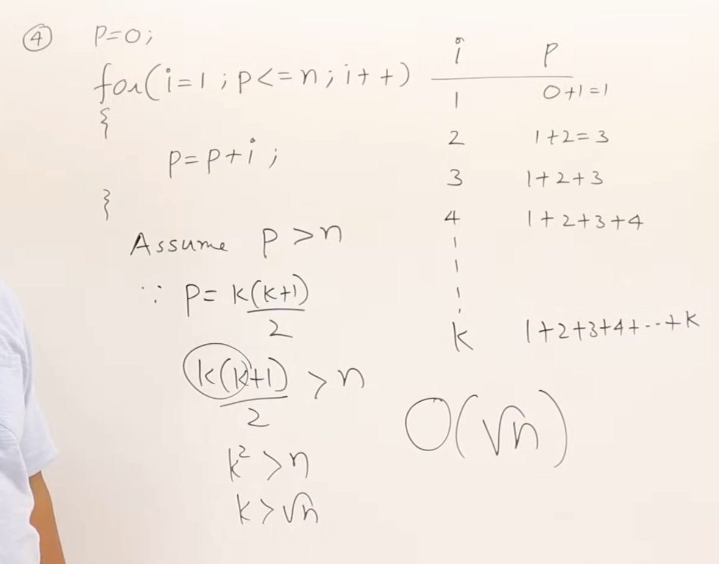

<https://youtu.be/9SgLBjXqwd4?si=EfuZHWN3JL9hR-q->

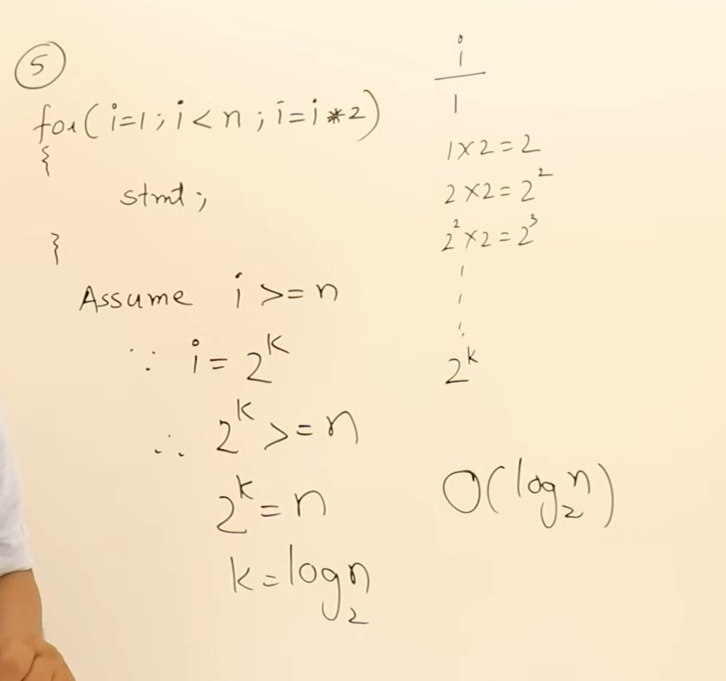

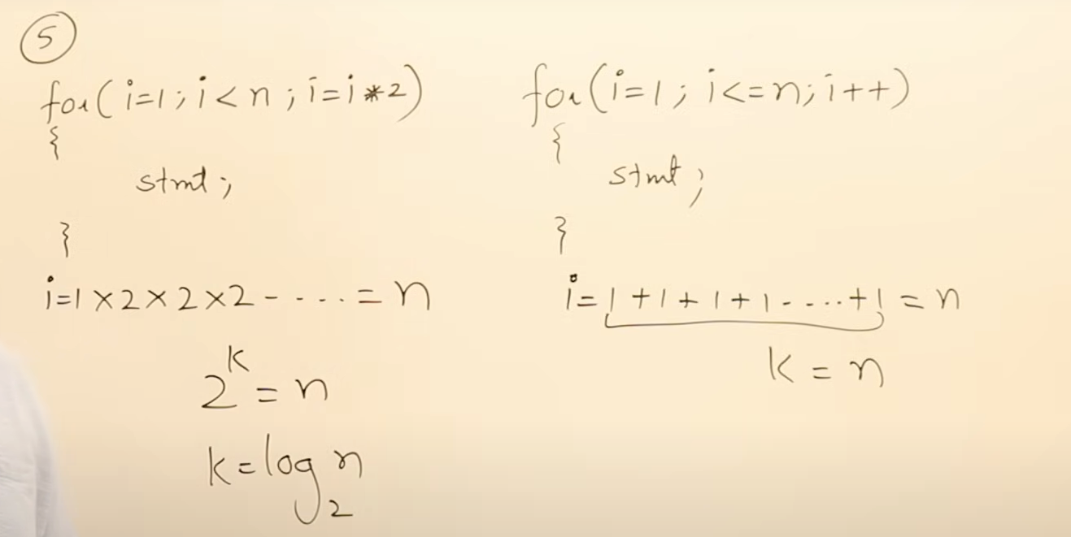

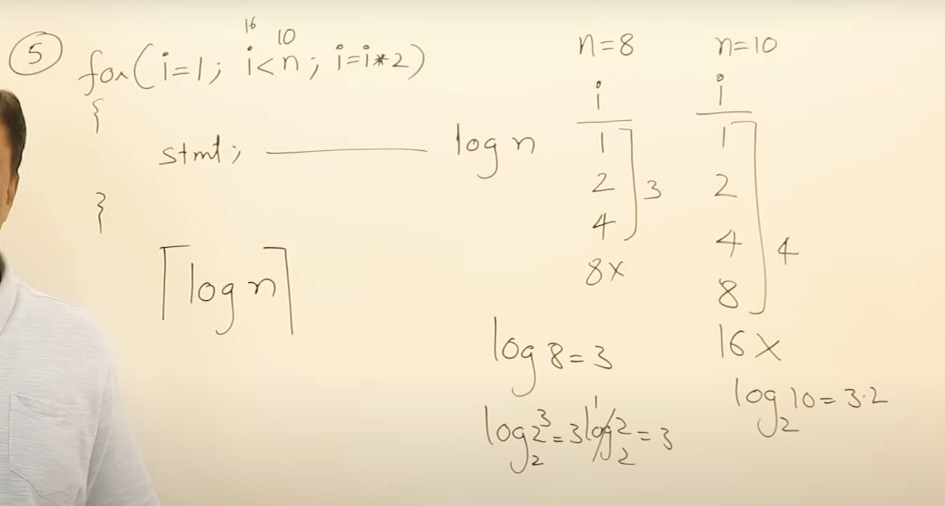its ceil of logN..  
  
ceil or floor is also important..

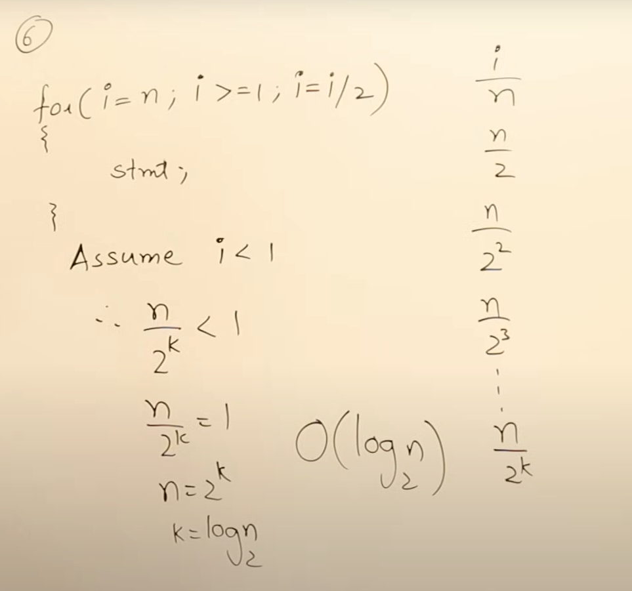

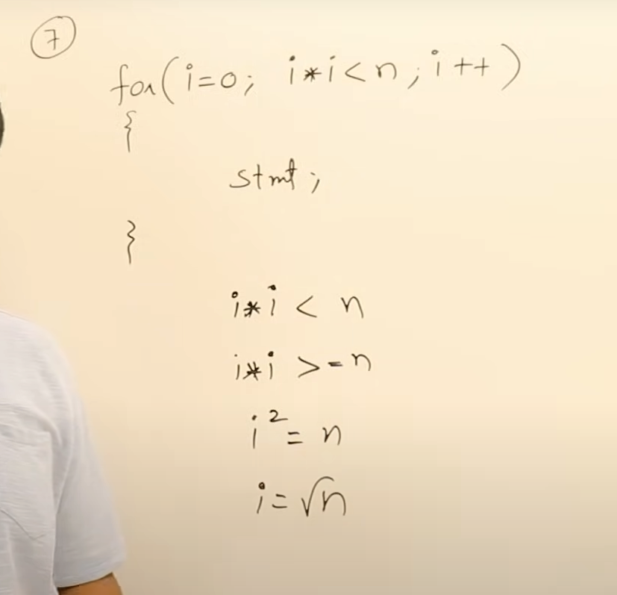

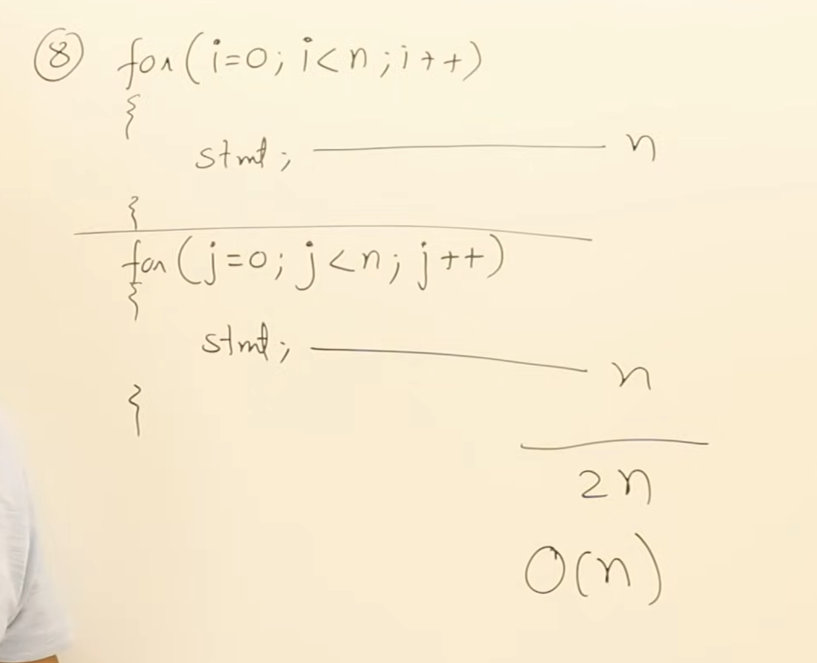

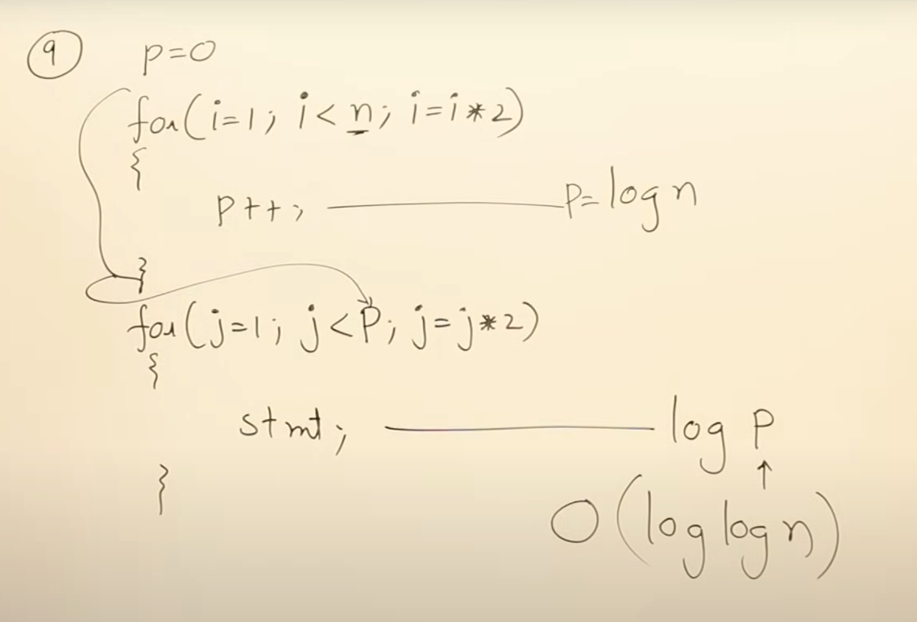

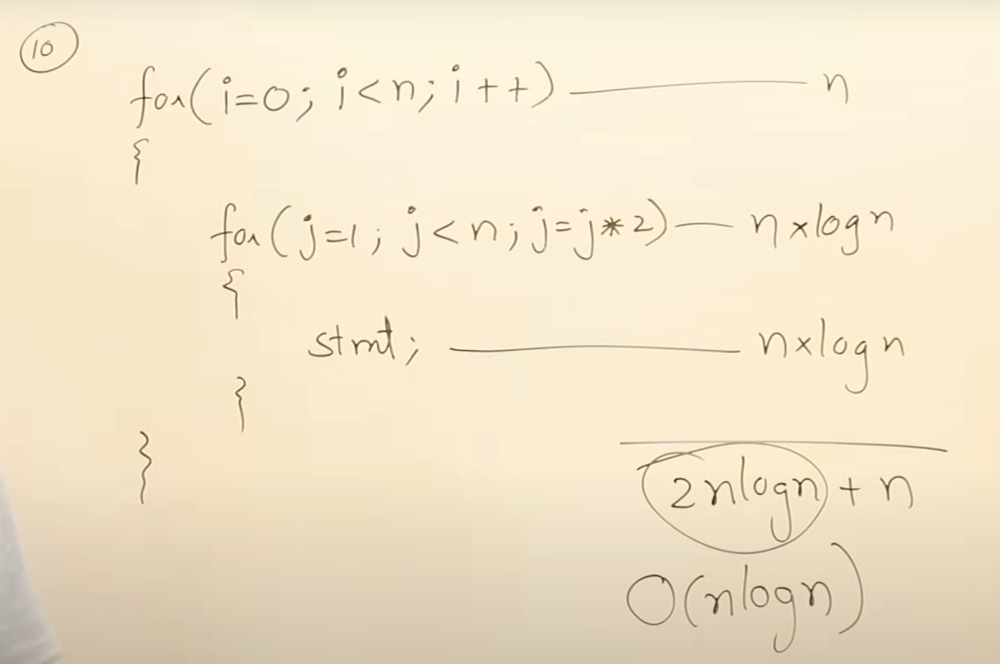

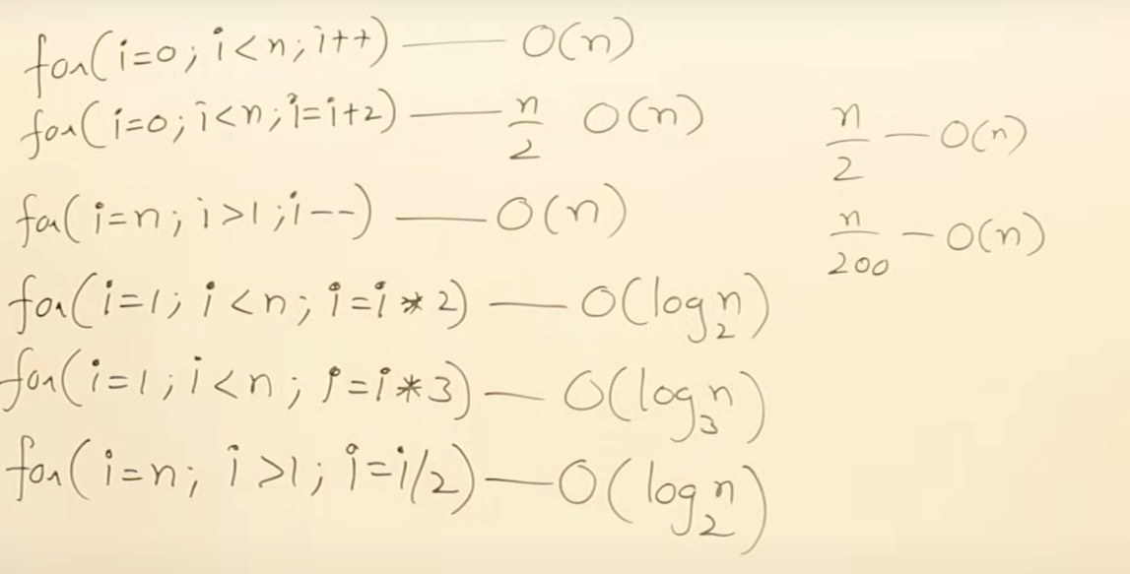

### Analysis of Time Complexity for Various Code Snippets

Let's break down the analysis and time complexity of different code examples, focusing on loops and their complexities.

#### **1. Loop with Multiplicative Growth**

**Code Snippet**:

```c

for (int i = 1; i < n; i *= 2) {

// Constant time operation

}

```

**Analysis**:

- **Initial Value**: `i = 1`

- **Growth**: `i` is multiplied by 2 each time: `1, 2, 4, 8, ...`

- **Termination Condition**: The loop continues while `i < n`.

**Find Number of Iterations**:

- `i` grows as powers of 2: `2^0, 2^1, 2^2, ..., 2^k`

- The loop stops when `2^k >= n`.

- Solving for `k`: `2^k = n` ⇒ `k = log₂(n)`

**Time Complexity**: \( O(\log n) \)

**Note**: If the multiplier were different (e.g., `i *= 3`), the complexity would be \( O(\log_b n) \), where \( b \) is the multiplier.

---

#### **2. Loop with Incremental Growth**

**Code Snippet**:

```c

for (int i = 1; i <= n; i++) {

// Constant time operation

}

```

**Analysis**:

- **Initial Value**: `i = 1`

- **Growth**: `i` is incremented by 1 each time: `1, 2, 3, ..., n`

**Number of Iterations**:

- The loop runs from `i = 1` to `i = n`.

**Time Complexity**: \( O(n) \)

---

#### **3. Loop with Division**

**Code Snippet**:

```c

for (int i = n; i > 0; i /= 2) {

// Constant time operation

}

```

**Analysis**:

- **Initial Value**: `i = n`

- **Growth**: `i` is divided by 2 each time: `n, n/2, n/4, ..., 1`

**Find Number of Iterations**:

- `i` decreases as powers of 2: `n, n/2, n/4, ..., 1`

- The loop stops when `i < 1`.

**Time Complexity**: \( O(\log n) \)

---

#### **4. Loop with Quadratic Growth**

**Code Snippet**:

```c

for (int i = 1; i * i <= n; i++) {

// Constant time operation

}

```

**Analysis**:

- **Condition**: The loop continues while `i^2 <= n`.

- Solving for `i`: `i ≤ √n`.

**Time Complexity**: \( O(\sqrt{n}) \)

---

#### **5. Nested Loops with Multiplicative Growth**

**Code Snippet**:

```c

for (int i = 1; i < n; i *= 2) {

for (int j = 1; j < n; j++) {

// Constant time operation

}

}

```

**Analysis**:

- **Outer Loop**: Runs \( O(\log n) \) times.

- **Inner Loop**: Runs \( O(n) \) times.

**Total Time Complexity**:

- **Overall Complexity**: \( O(n \log n) \)

---

#### **6. Independent Loops**

**Code Snippet**:

```c

for (int i = 0; i < n; i++) {

// Constant time operation

}

for (int j = 0; j < n; j++) {

// Constant time operation

}

```

**Analysis**:

- **First Loop**: \( O(n) \)

- **Second Loop**: \( O(n) \)

- **Combined Time Complexity**: \( O(n + n) = O(n) \)

---

#### **7. Logarithmic in Terms of Logarithms**

**Code Snippet**:

```c

int P = 0;

for (int i = 1; P <= n; i *= 2) {

P += i;

}

```

**Analysis**:

- **Initial Value**: `P = 0`

- **Growth of `i`**: `1, 2, 4, 8, ...`

- **Total Number of Iterations**: The loop will execute for \( O(\log n) \) times, and `P` will be roughly \( O(\log n) \).

**Time Complexity**: \( O(\log(\log n)) \)

---

### **Summary**

1. **Multiplicative Growth Loop**:

- **Time Complexity**: \( O(\log n) \)

2. **Incremental Growth Loop**:

- **Time Complexity**: \( O(n) \)

3. **Division Growth Loop**:

- **Time Complexity**: \( O(\log n) \)

4. **Quadratic Growth Loop**:

- **Time Complexity**: \( O(\sqrt{n}) \)

5. **Nested Loops with Multiplicative Growth**:

- **Time Complexity**: \( O(n \log n) \)

6. **Independent Loops**:

- **Time Complexity**: \( O(n) \)

7. **Logarithmic in Terms of Logarithms**:

- **Time Complexity**: \( O(\log(\log n)) \)

This analysis should help you understand how to approach and determine the time complexity for various types of loops and nested loops in code.

@ <https://youtu.be/p1EnSvS3urU?si=J25X28Mk86gOuK1i>

Time complexity for if and conditional statements:

Currently For loop and while loop basically same..

But old languages normal loop i.e just O(N) loops are written in for, others in while..

Do while and repeat until:  
both exec the first time without checking condition, but doWhile exec until condition is true but repeatUntil exec as long as condition is false ( i.e do this until it happens ) …

Old looping things:

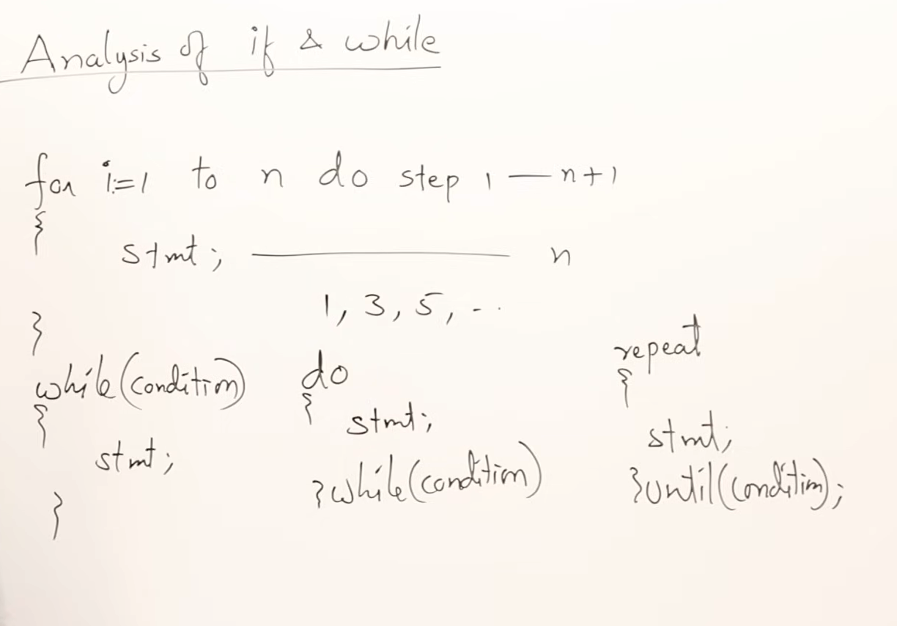

In old lang, for FOR loops, we can simple put O(n) as time complexity, but for others, we need to analyze…

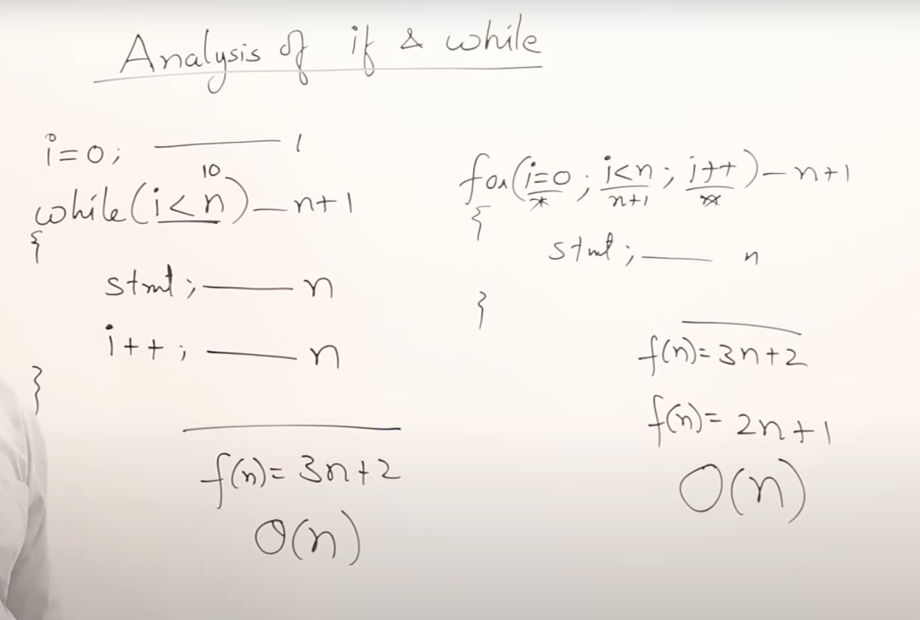

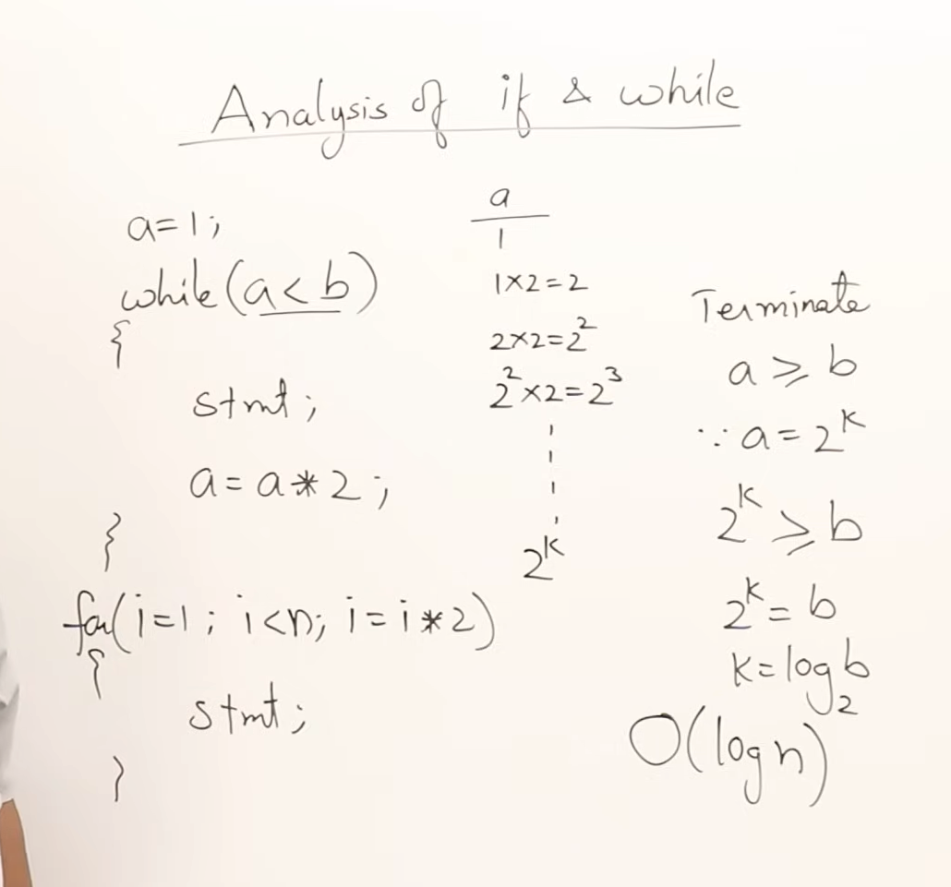

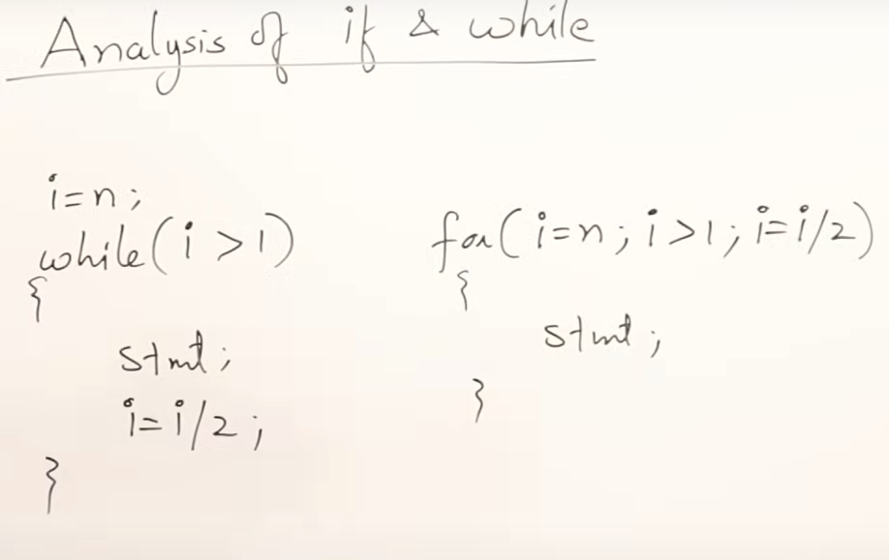

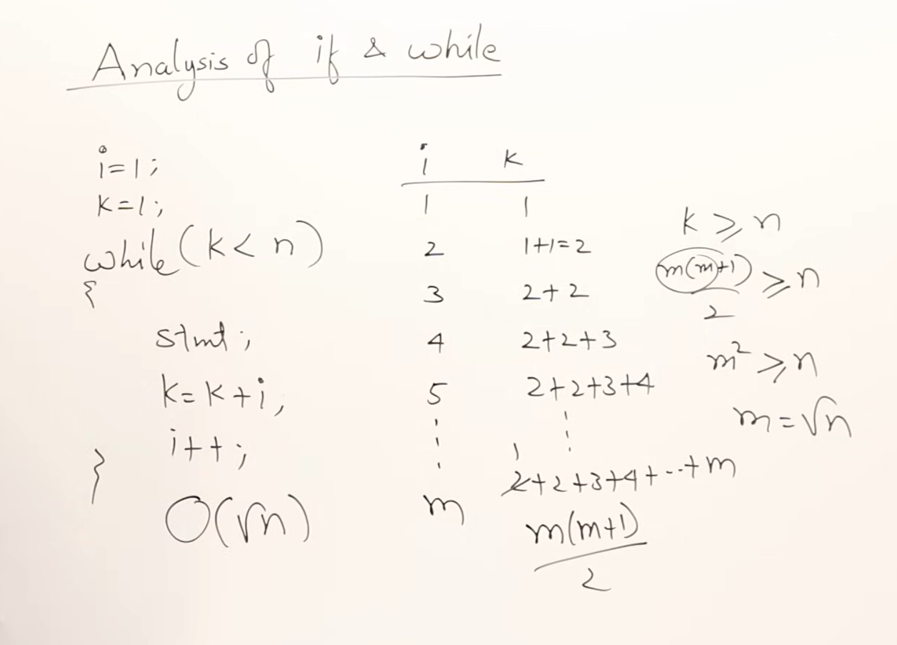

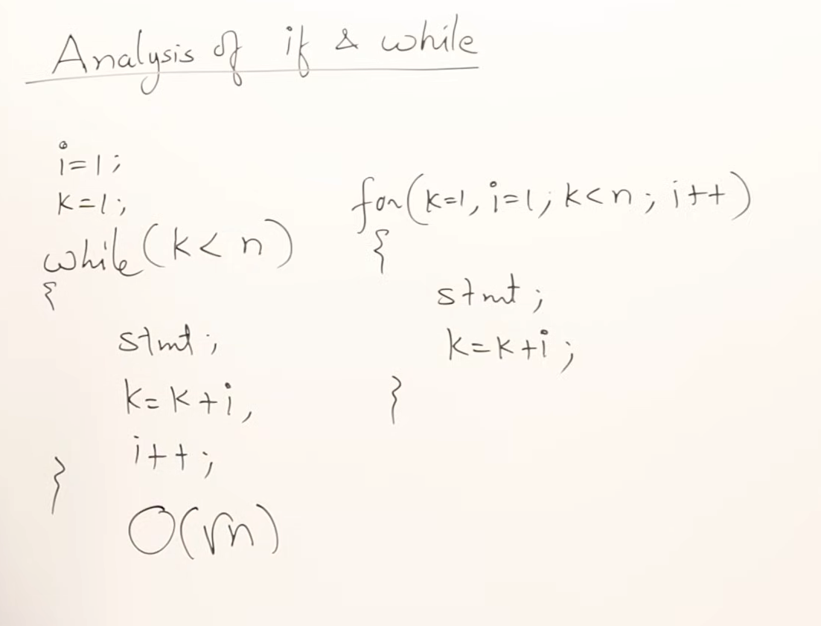

Gcd of 2 nums  
  
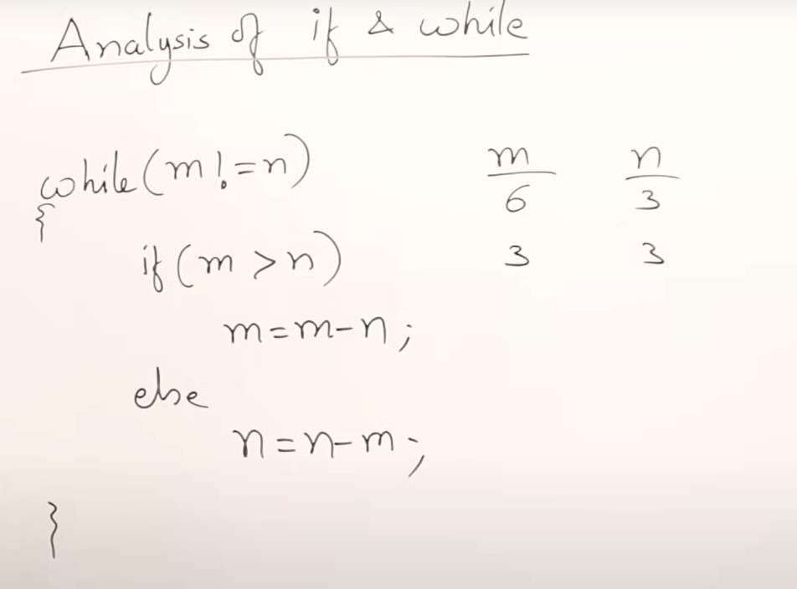

It sounds like you're explaining how to determine the time complexity of loops in programming, particularly focusing on `for` loops, `while` loops, `do-while` loops, and conditional statements. Let’s break down some key points and simplify them for clarity:

### **Analyzing Time Complexity for Different Types of Loops**

#### **1. `for` Loop**

A `for` loop typically has a straightforward time complexity because you can directly see the number of iterations:

```c

for (int i = 0; i < n; i++) {

// some constant-time operations

}

```

- **Time Complexity**: \( O(n) \)

- The loop runs `n` times if the loop variable is incremented linearly.

#### **2. `while` Loop**

A `while` loop continues until a condition becomes false. Its complexity depends on how quickly the condition becomes false:

```c

int i = 0;

while (i < n) {

// some constant-time operations

i++;

}

```

- **Time Complexity**: \( O(n) \)

- If `i` starts at 0 and is incremented until it reaches `n`, it will execute `n` times.

#### **3. `do-while` Loop**

The `do-while` loop guarantees at least one execution because the condition is checked after the loop body:

```c

int i = 0;

do {

// some constant-time operations

i++;

} while (i < n);

```

- **Time Complexity**: \( O(n) \)

- Like the `while` loop, it will also execute `n` times in the worst case, but it guarantees at least one execution.

### **Complexity of Other Patterns**

#### **1. Exponential Growth**

When a variable grows exponentially, such as doubling each time:

```c

int a = 1;

while (a < n) {

// some constant-time operations

a *= 2;

}

```

- **Time Complexity**: \( O(\log n) \)

- The loop runs as long as `a` is less than `n`, and `a` doubles each iteration, so the number of iterations is proportional to the logarithm of `n`.

#### **2. Sum of Series**

For loops that involve summing a series:

```c

int k = 1;

while (k < n) {

int i = 1;

while (i < k) {

// some constant-time operations

i++;

}

k++;

}

```

- **Time Complexity**:

- The inner loop runs `k` times for each `k`, and `k` ranges from `1` to `n`, so the total number of iterations can be approximated by the sum of the first `n` natural numbers: \( O(n^2) \).

### **Conditional Statements**

Conditional statements in algorithms can create different scenarios:

```c

if (n < 5) {

// some constant-time operations

} else {

// another set of constant-time operations

}

```

- **Best Case**: If the condition is true and the code in the `if` block runs, the time complexity could be \( O(1) \).

- **Worst Case**: If the condition is false and the code in the `else` block runs, it might be \( O(n) \) or any other complexity depending on the operations.

### **Summary**

- **`for` Loop**: Time complexity is usually straightforward to determine, \( O(n) \).

- **`while` Loop**: Depends on the condition; can also be \( O(n) \).

- **`do-while` Loop**: Similar to `while` but guarantees at least one iteration.

- **Exponential Growth**: Often \( O(\log n) \).

- **Sum of Series**: May lead to \( O(n^2) \) or higher depending on the series.

- **Conditional Statements**: Can vary from \( O(1) \) to \( O(n) \) depending on the context.

Understanding how each type of loop and conditional statement operates and analyzing the number of iterations they produce will help in determining the time complexity of the code.

GCD things:

Absolutely! Let's dive into the GCD (Greatest Common Divisor) example and analyze its time complexity. We’ll discuss two common methods for finding the GCD: the **subtraction-based method** and the **Euclidean algorithm**.

### **1. Subtraction-Based GCD Algorithm**

Here’s how the subtraction-based method works:

```c

int gcd(int m, int n) {

while (m != n) {

if (m > n) {

m = m - n;

} else {

n = n - m;

}

}

return m;

}

```

#### **Analysis:**

- **Initial Observation:**

- Each iteration of the `while` loop reduces either `m` or `n` by the value of the other variable.

- If the difference between `m` and `n` is relatively large, the reduction per iteration is substantial, but in the worst case, it may reduce very slowly.

- **Time Complexity:**

- In the worst case, where `m` and `n` are close to each other, the loop may need to run `O(n)` times if `n` is the smaller number.

- For instance, if `m` is a multiple of `n`, then the difference reduction will be slow, leading to a maximum of `O(m)` iterations.

Hence, the time complexity of this subtraction-based GCD algorithm is **O(max(m, n))**.

### **2. Euclidean Algorithm**

The Euclidean algorithm is more efficient and commonly used for finding the GCD:

```c

int gcd(int m, int n) {

while (n != 0) {

int temp = n;

n = m % n;

m = temp;

}

return m;

}

```

#### **Analysis:**

- **Initial Observation:**

- This method uses the modulus operator to reduce the problem size significantly in each step.

- Each step replaces the larger number `m` with the remainder when divided by `n`, which is smaller than `n`.

- **Time Complexity:**

- The time complexity of the Euclidean algorithm can be analyzed using the properties of the modulus operation.

- The number of steps required is proportional to the number of digits in the smaller number.

- The Euclidean algorithm has a logarithmic time complexity relative to the size of the numbers involved because the size of the numbers involved is reduced significantly in each step.

Thus, the time complexity of the Euclidean algorithm is **O(log(min(m, n)))**.

### **Summary of GCD Algorithms**

1. **Subtraction-Based Method:**

- **Code Example:**

```c

int gcd(int m, int n) {

while (m != n) {

if (m > n) {

m = m - n;

} else {

n = n - m;

}

}

return m;

}

```

- **Time Complexity:** \( O(\max(m, n)) \)

2. **Euclidean Algorithm:**

- **Code Example:**

```c

int gcd(int m, int n) {

while (n != 0) {

int temp = n;

n = m % n;

m = temp;

}

return m;

}

```

- **Time Complexity:** \( O(\log(\min(m, n))) \)

The Euclidean algorithm is typically preferred due to its better time complexity. Understanding these methods helps in analyzing algorithms that use GCD as part of their solution.

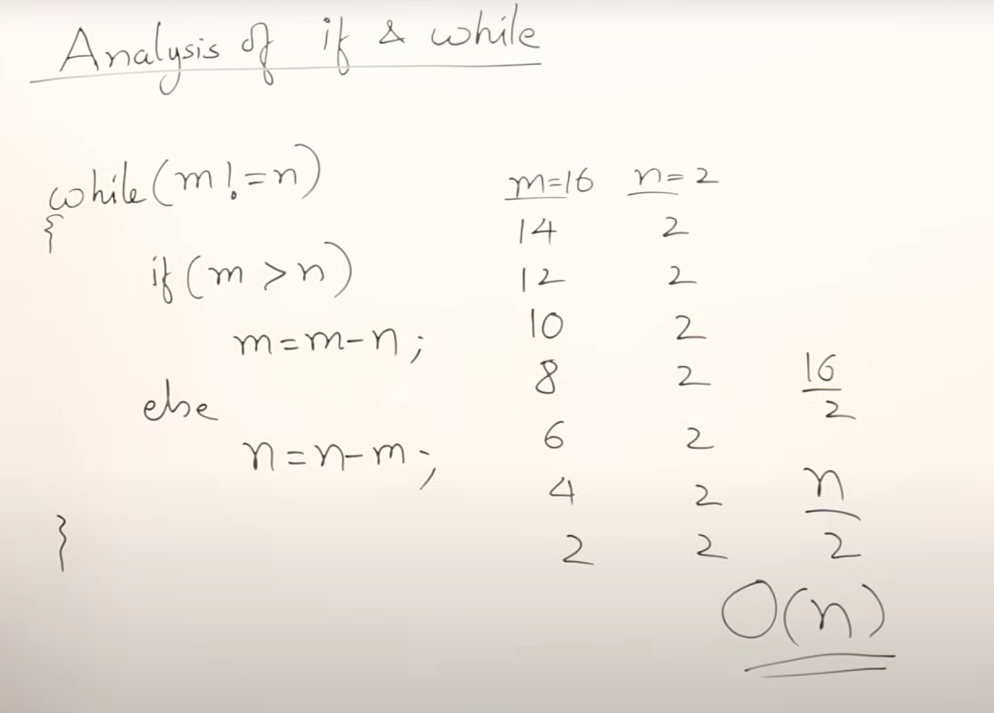

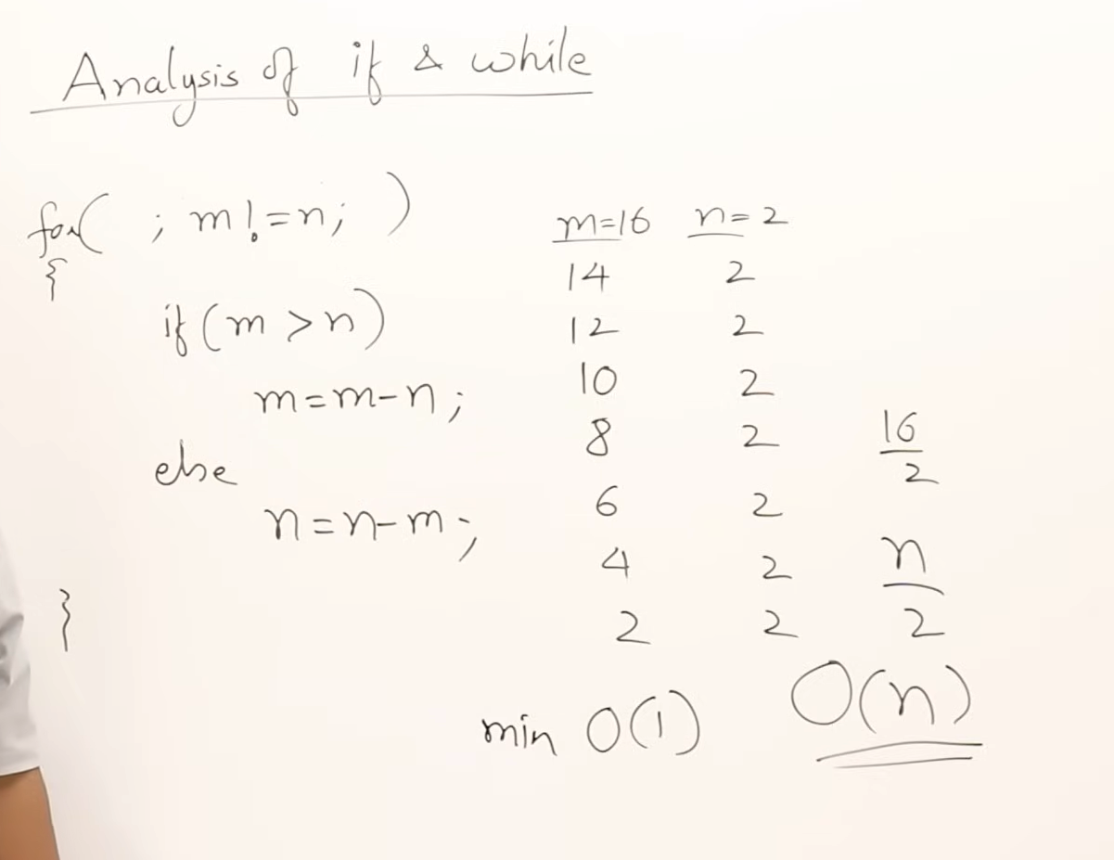

For complexities, we take worst case timings as final..  
the maximum time for this algo is O(n), min time is O(1)

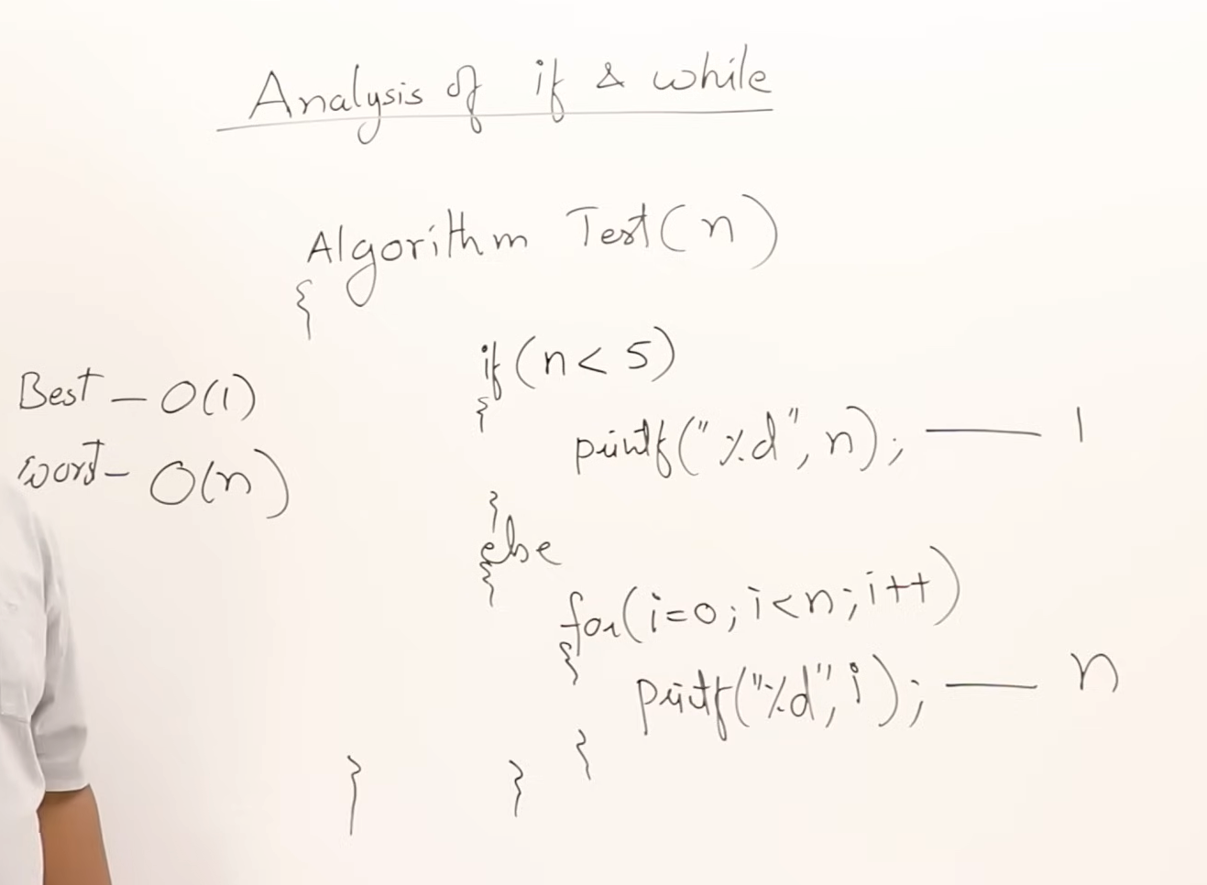

Types of time functions:

Basically we take only degree of polynomial that we are getting from algoritham..

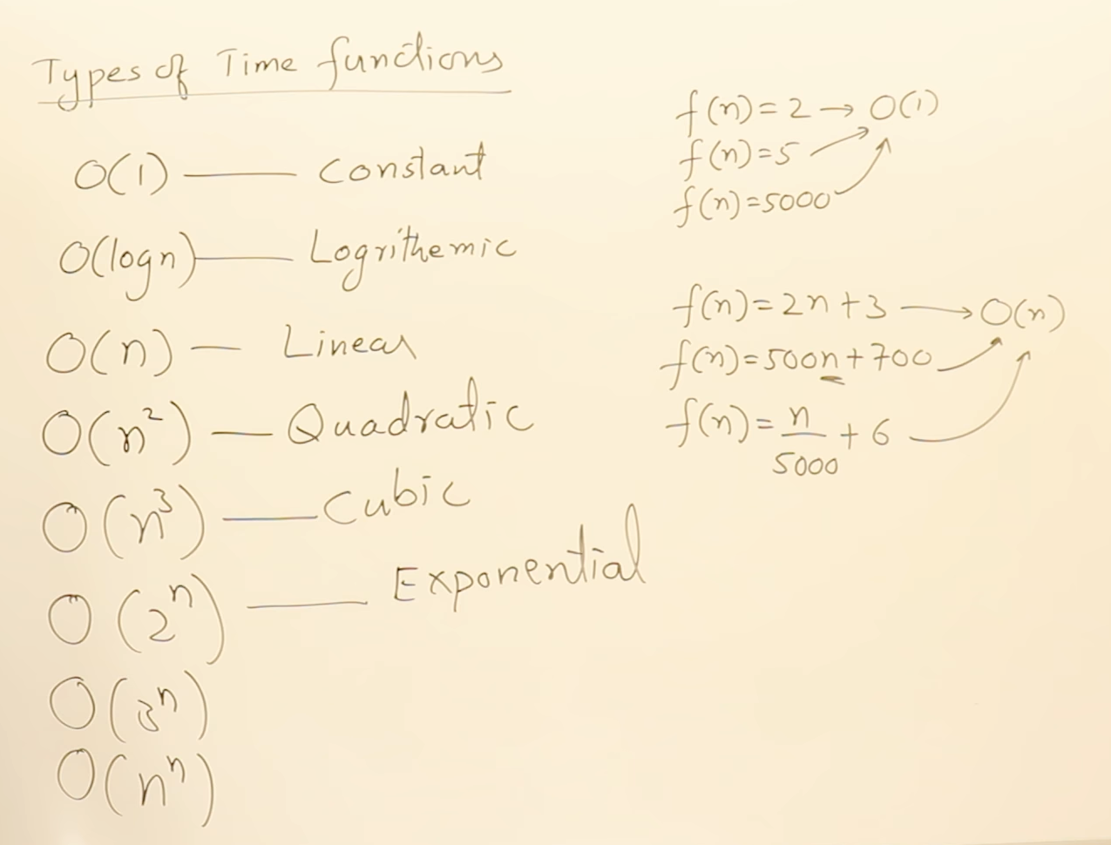

1. **Constant Time (O(1))**: Functions that do not depend on the size of the input. Whether the function returns 2, 5, or 5000, it's still constant as the time taken remains the same, irrespective of the input size.
2. **Logarithmic Time (O(log n))**: Time complexity depends on the logarithm of the input size, regardless of the base (e.g., log base 2 or 3).
3. **Linear Time (O(n))**: Time complexity grows linearly with the input size. Even if the function has additional constants (e.g., 2n + 3 or 500n + 700), it is still considered O(n) because the degree of the polynomial is 1.
4. **Quadratic Time (O(n^2))**: For algorithms where the time complexity is proportional to the square of the input size, often seen in matrix multiplication.
5. **Cubic Time (O(n^3))**: Time complexity that grows cubically with the input size, such as some more complex matrix operations.
6. **Exponential Time (O(2^n), O(3^n), or O(n^n))**: This class of algorithms grows extremely quickly as the input size increases and is often impractical for large inputs.

These time complexities are grouped into different classes, such as linear, logarithmic, quadratic, cubic, and exponential, depending on the type of function.

Compare time functions:

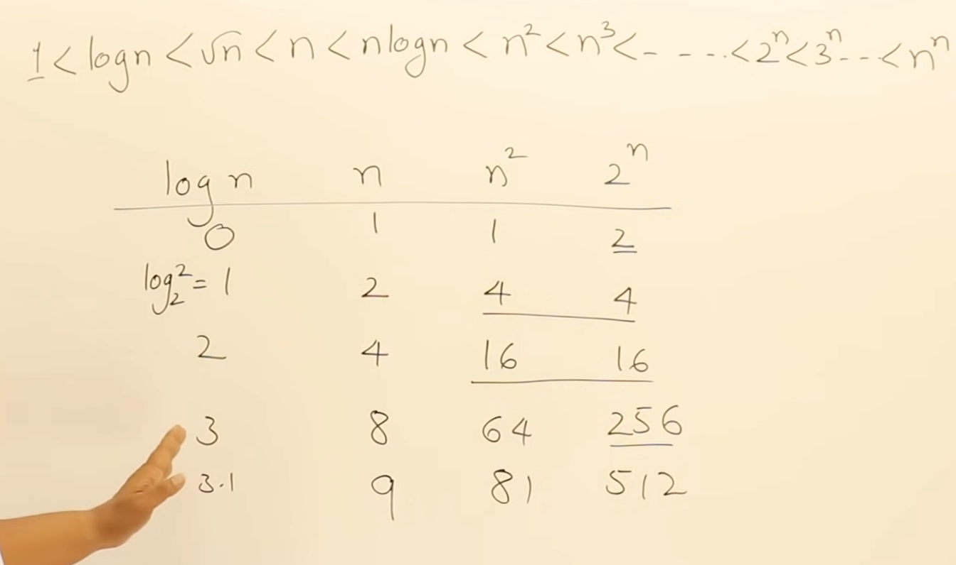

N**2 and 2**N seems to be controversial, but from some point, 2**N will become very greater than N**2… ( intailly 2**N may be smaller than N**2 )

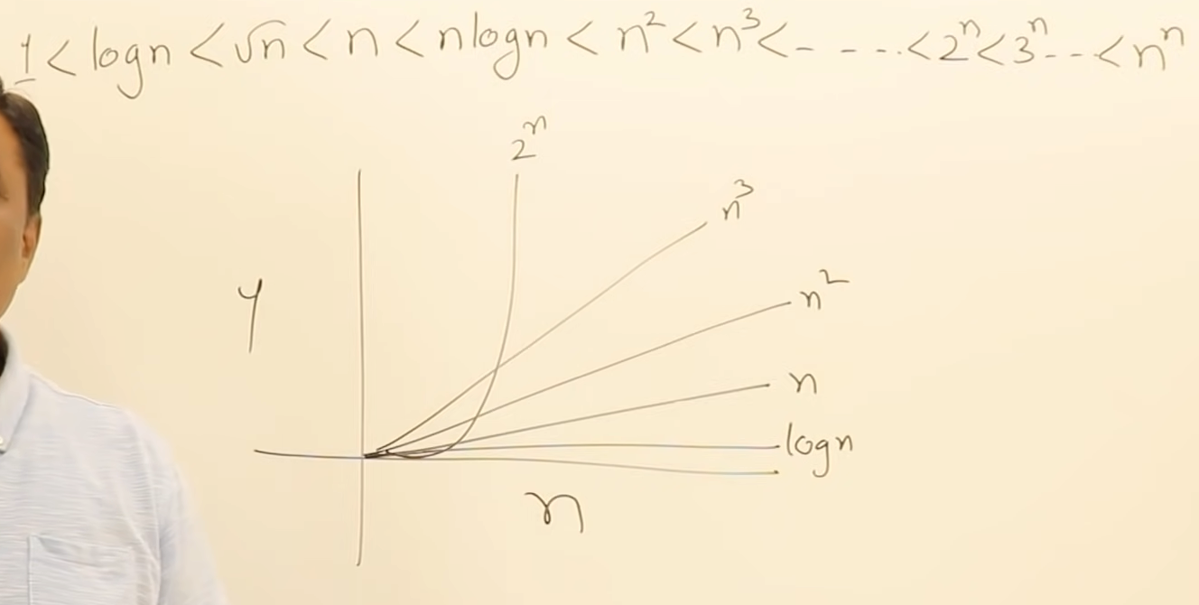

**Summary for a Lecture on Time Complexity Growth and Function Classes**

**Introduction to Time Complexity Classes:** Time complexity describes how the performance of an algorithm scales with the size of the input. Different algorithms exhibit different growth rates, and these growth rates can be organized into classes based on how quickly they increase. Understanding these classes helps us to determine the efficiency of an algorithm for large input sizes.

**Order of Growth (From Slowest to Fastest):** We arrange the time complexity classes in increasing order based on how their computational weight grows with the input size (n). Here's the order from slowest growth to fastest:

1. **Constant Time (O(1))**:
   * Operations that take the same amount of time regardless of input size.
2. **Logarithmic Time (O(log n))**:
   * The algorithm's time grows very slowly, even as input size increases. Examples include binary search.
3. **Linear Time (O(n))**:
   * The time grows in direct proportion to the input size. Many simple iterative processes fall into this category.
4. **Linearithmic Time (O(n log n))**:
   * Common in more advanced sorting algorithms like merge sort.
5. **Quadratic Time (O(n²))**:
   * As input size increases, the time required grows quadratically. Examples include simple sorting algorithms like bubble sort or selection sort.
6. **Cubic Time (O(n³))**:
   * Growth rate increases even faster than quadratic time. Some matrix operations fall into this category.
7. **Polynomial Time (O(n^k))**:
   * This class represents any polynomial time function where the exponent (k) can vary, such as n⁴ or n⁵. Although slower, these functions are still feasible for moderate-sized inputs.
8. **Exponential Time (O(2^n), O(3^n))**:
   * Exponential growth is extremely fast, and algorithms in this class become impractical as input size grows. Examples include brute force solutions for problems like the traveling salesman problem.

**Comparing Growth with Examples:** To visualize how these functions grow, we take specific values of "n" (e.g., 1, 2, 4, 8) and observe the output of different time complexities. Initially, for small values of "n", the differences between these classes might not seem significant. However, as "n" increases, the gap between the growth rates becomes much larger. For instance:

* Logarithmic and linear growth remain relatively slow.
* Polynomial and exponential growth start to diverge rapidly as "n" increases, with exponential functions quickly overtaking all polynomial functions.

**Key Insight - Exponential Growth:** One critical insight is that **exponential growth (O(2^n)) will always outpace any polynomial growth (O(n^k))** for sufficiently large values of "n"**. This means that even if a function has an exponent of 100 (O(n^100)), it will still grow slower than O(2^n) for large enough input sizes.

**Graphical Representation:** A graph plotting the functions shows that initially, some functions like logarithmic, linear, and even quadratic may seem close, but beyond a certain input size, exponential growth dominates. Thus, understanding this distinction is crucial for analyzing algorithm efficiency.

**Conclusion - Importance of Arrangement:** The arrangement of these function classes in increasing order of growth is fundamental when evaluating algorithms. For practical purposes, it's critical to select algorithms with a lower time complexity for large inputs, as they will be more efficient in terms of execution time. The exponential and polynomial classes may be computationally prohibitive for large datasets, while linear or logarithmic time complexities are preferred in these cases.

This ordering and understanding help ensure that we choose the right algorithm for the right task, balancing both the problem size and the computational resources required.

Asymptotic Notations:

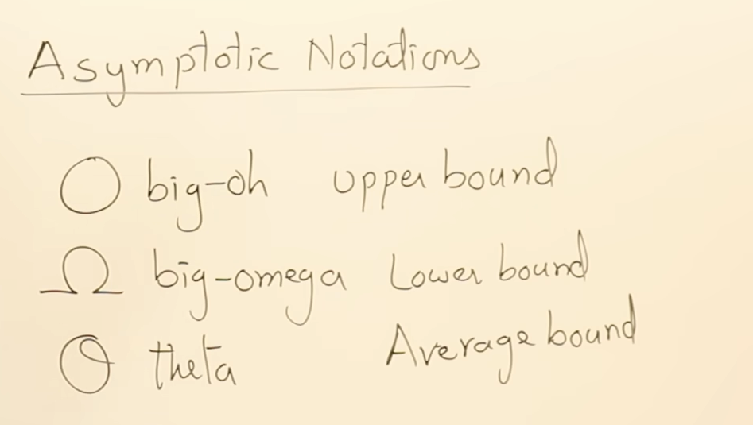

**Summary of Asymptotic Notation in Algorithms**

**Introduction to Asymptotic Notation:** Asymptotic notation is a fundamental concept in algorithms that helps describe the behavior of a function (often time complexity) as the input size grows. It is derived from mathematics and is essential for understanding the efficiency of algorithms in a communicable, simplified manner.

There are three main notations used to represent the upper, lower, and average bounds of a function:

1. **Big O Notation (O)** – Represents the *upper bound* of a function.
2. **Omega Notation (Ω)** – Represents the *lower bound* of a function.
3. **Theta Notation (Θ)** – Represents the *average bound* of a function.

**1. Big O Notation (O) - *Upper Bound***

* **Definition**: Big O notation describes the worst-case scenario or the maximum time an algorithm will take. Formally, a function f(n)f(n)f(n) is O(g(n))O(g(n))O(g(n)) if there exist constants ccc and n0n_0n0​ such that f(n)≤c⋅g(n)f(n) \leq c \cdot g(n)f(n)≤c⋅g(n) for all n≥n0n \geq n_0n≥n0​.
* **Example**:
  + For f(n)=2n+3f(n) = 2n + 3f(n)=2n+3, we can say f(n)≤10nf(n) \leq 10nf(n)≤10n, making f(n)=O(n)f(n) = O(n)f(n)=O(n).
  + Other examples like O(n2)O(n^2)O(n2) are also possible, but it's recommended to use the closest function for the upper bound.
* **Key Takeaway**: Big O represents an upper bound, meaning it gives the worst-case time complexity, even if the function behaves better in practice. For example, even if the function is O(n2)O(n^2)O(n2), it might behave better for smaller inputs. The closest, tightest upper bound should always be preferred.

**2. Omega Notation (Ω) - *Lower Bound***

* **Definition**: Omega notation describes the *best-case* or the minimum time an algorithm can take. A function f(n)f(n)f(n) is Ω(g(n))\Omega(g(n))Ω(g(n)) if there exist constants ccc and n0n_0n0​ such that f(n)≥c⋅g(n)f(n) \geq c \cdot g(n)f(n)≥c⋅g(n) for all n≥n0n \geq n_0n≥n0​.
* **Example**:
  + For f(n)=2n+3f(n) = 2n + 3f(n)=2n+3, we can say f(n)≥nf(n) \geq nf(n)≥n, making f(n)=Ω(n)f(n) = \Omega(n)f(n)=Ω(n).
  + Similarly, we can use Ω(log⁡n)\Omega(\log n)Ω(logn), but it must reflect the lower bound appropriately.
* **Key Takeaway**: Omega notation gives the lower bound, meaning the algorithm will not perform better than this value, but it could be worse.

**3. Theta Notation (Θ) - *Average Bound***

* **Definition**: Theta notation represents the *exact* bound, showing both the upper and lower bounds at the same time. Formally, f(n)f(n)f(n) is Θ(g(n))\Theta(g(n))Θ(g(n)) if there exist constants c1c_1c1​, c2c_2c2​, and n0n_0n0​ such that c1⋅g(n)≤f(n)≤c2⋅g(n)c_1 \cdot g(n) \leq f(n) \leq c_2 \cdot g(n)c1​⋅g(n)≤f(n)≤c2​⋅g(n) for all n≥n0n \geq n_0n≥n0​.
* **Example**:
  + For f(n)=2n+3f(n) = 2n + 3f(n)=2n+3, we can say f(n)=Θ(n)f(n) = \Theta(n)f(n)=Θ(n), because the upper and lower bounds are the same.
  + If we try to say f(n)=Θ(n2)f(n) = \Theta(n^2)f(n)=Θ(n2), this would be incorrect since it would overestimate the growth.
* **Key Takeaway**: Theta is the most accurate representation of the function. If possible, use Theta as it provides the exact growth rate of the function. It is preferred over Big O or Omega when an exact match is possible.

**Key Points:**

1. **Big O is the most commonly used** notation because it provides a worst-case analysis, which is often the most important scenario to understand when analyzing algorithm efficiency.
2. **Omega is useful when understanding lower bounds**, but is less commonly used in practical algorithm analysis compared to Big O.
3. **Theta is ideal for representing both upper and lower bounds**, but it's not always possible to achieve this. When available, it is the most precise way to represent an algorithm’s performance.

**Common Misconceptions:**

* **Not Related to Best and Worst Case**: Big O, Omega, and Theta are often confused with best-case and worst-case scenarios. However, they do not inherently represent best or worst cases. Big O can represent the worst case, but Omega and Theta have specific uses based on bounds, not cases.

By using these notations, we simplify the analysis of algorithms and express the complexity in a form that is easier to communicate and understand. This also helps in comparing different algorithms and their scalability as the input size increases.